1. My Roaster

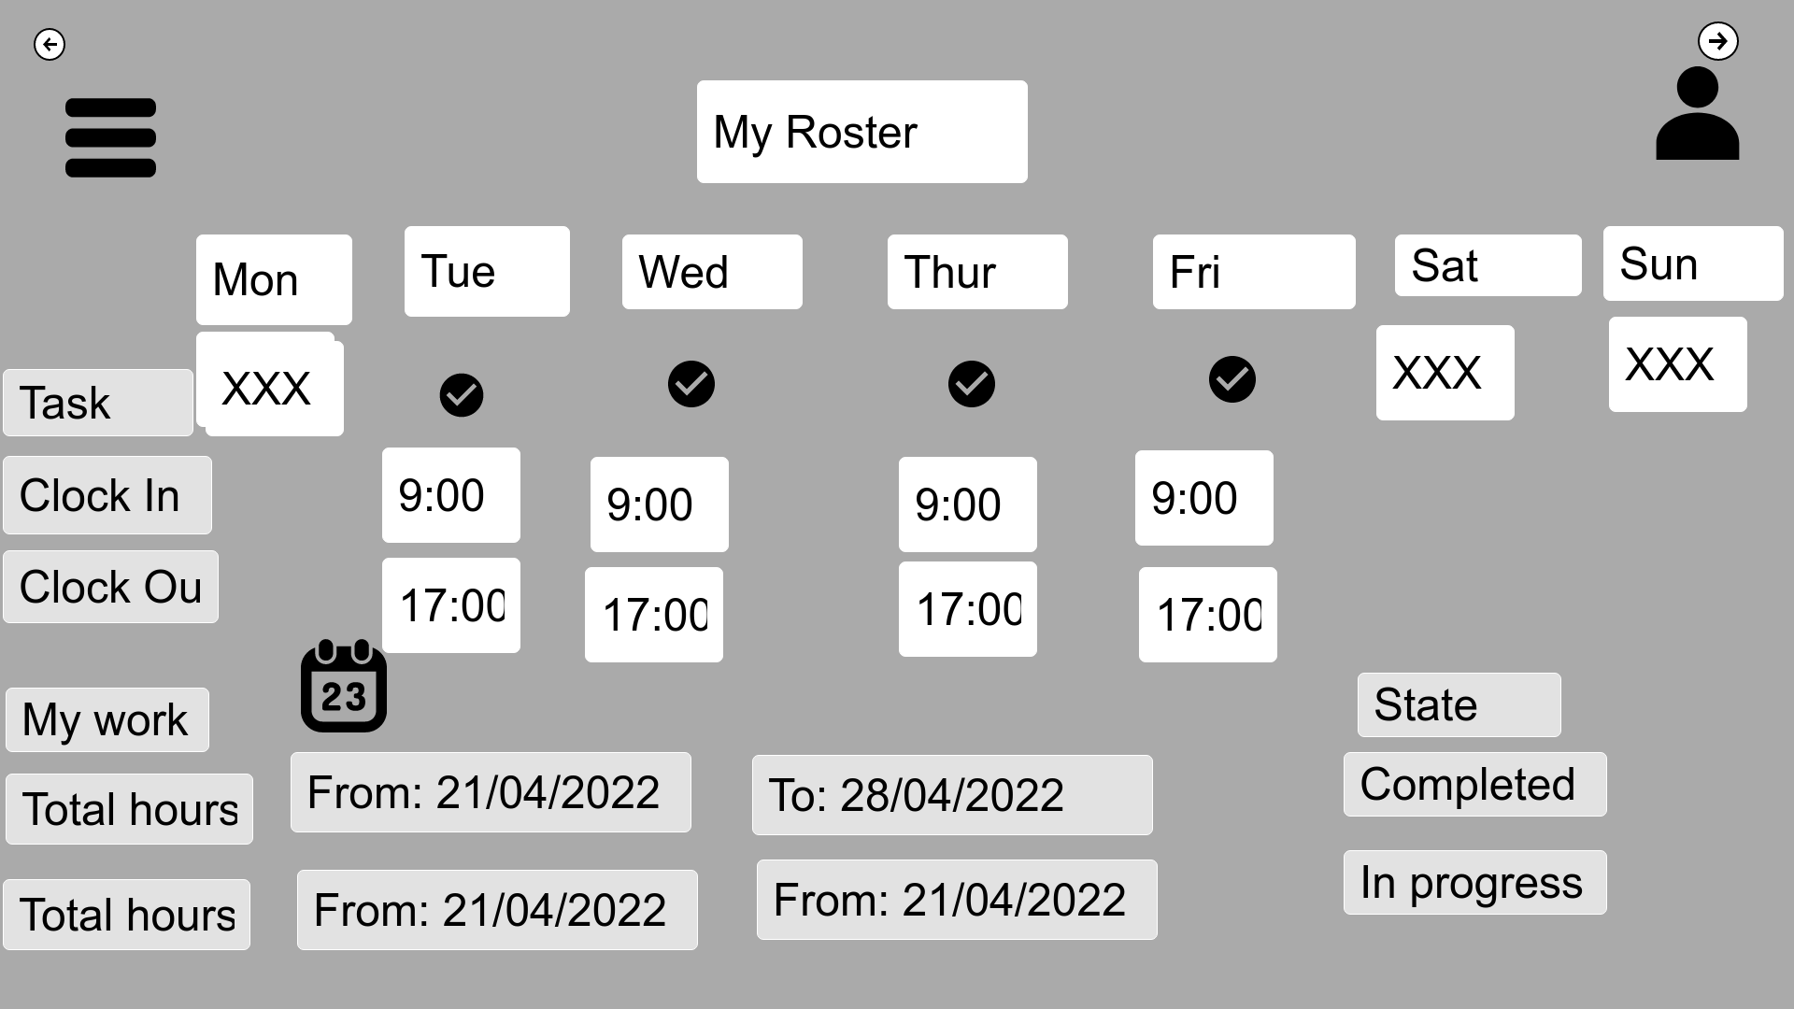

|  |  |
| --- | --- |
| Description: | My roster will have roster for a week. This page show start time of shift and end of shift on particular day. |
| Content | Days, my roster, clock in, clock out. Total hours, menu, profile, calendar. |
| Navigation | Navigation bar links to menu, profile, total working hours. |
| Graphic | Company logo on top left side. |

1. Clock In/out

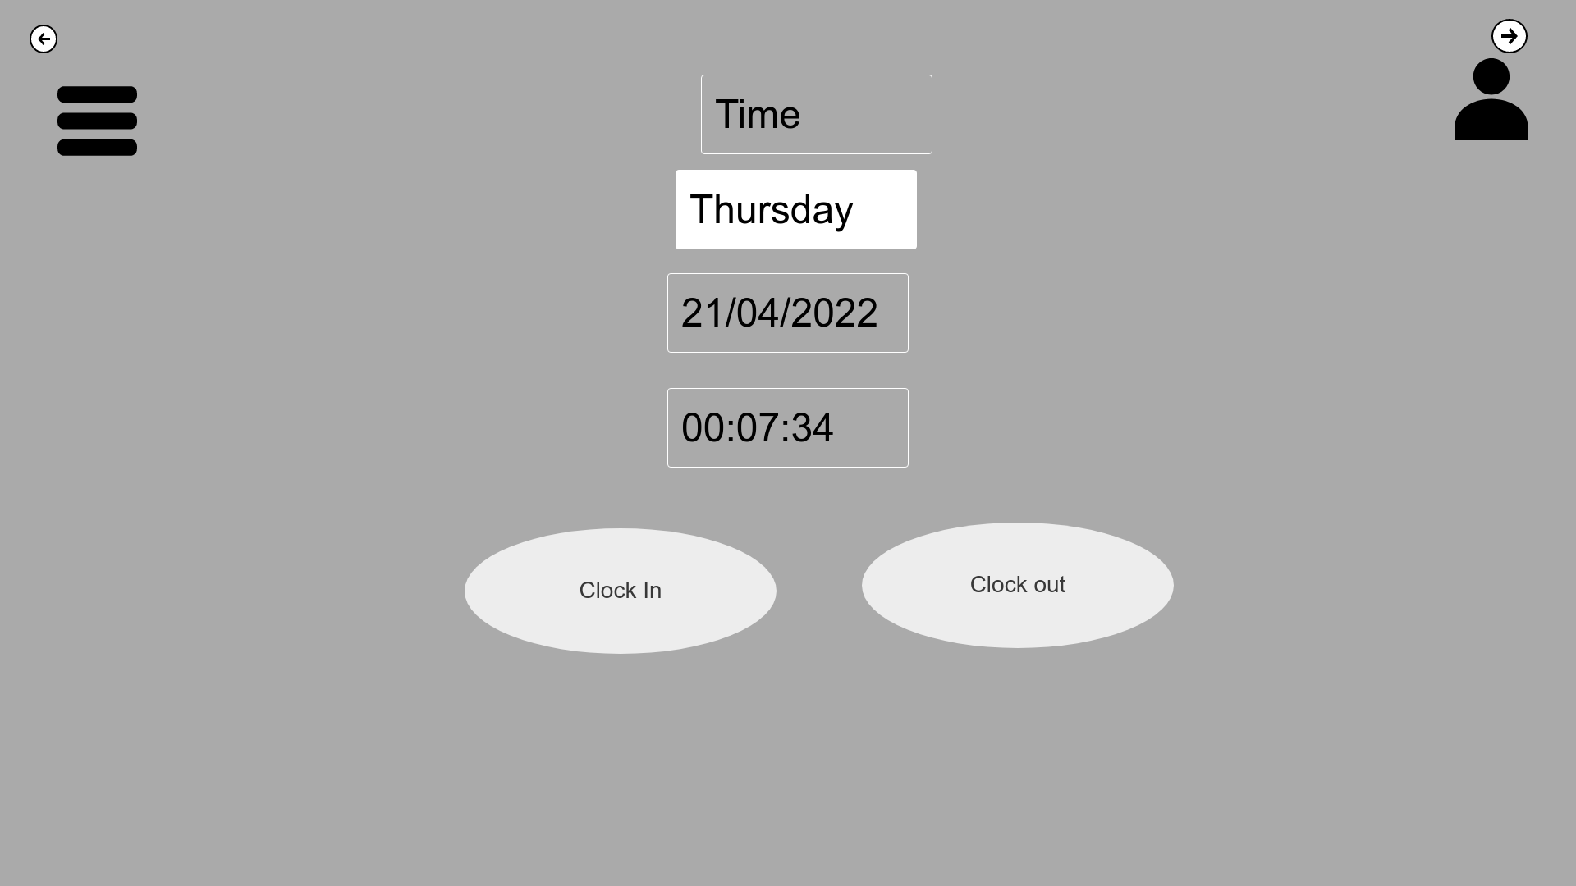

|  |  |
| --- | --- |
| Description: | Click on clock in /clock out menu then it will redirect to another page. where staff can click on clock in and punch at starting of shift and once shift is done staff can clock out and punch. The time between clock in and clock out punch will be recorded. Staff can clock in/out with in the company building, outside 500-meter range the system will show invalid. |
| Content | Date, time, day, menu, profile, Clock in and clock out |
| Navigation | Navigation bar links to menu, profile, clock in/out, profile. After entering all the detail user can clock in at beginning of shift and clock out at end of shift. |
| Graphic | Company logo on top left side. |

1. Training

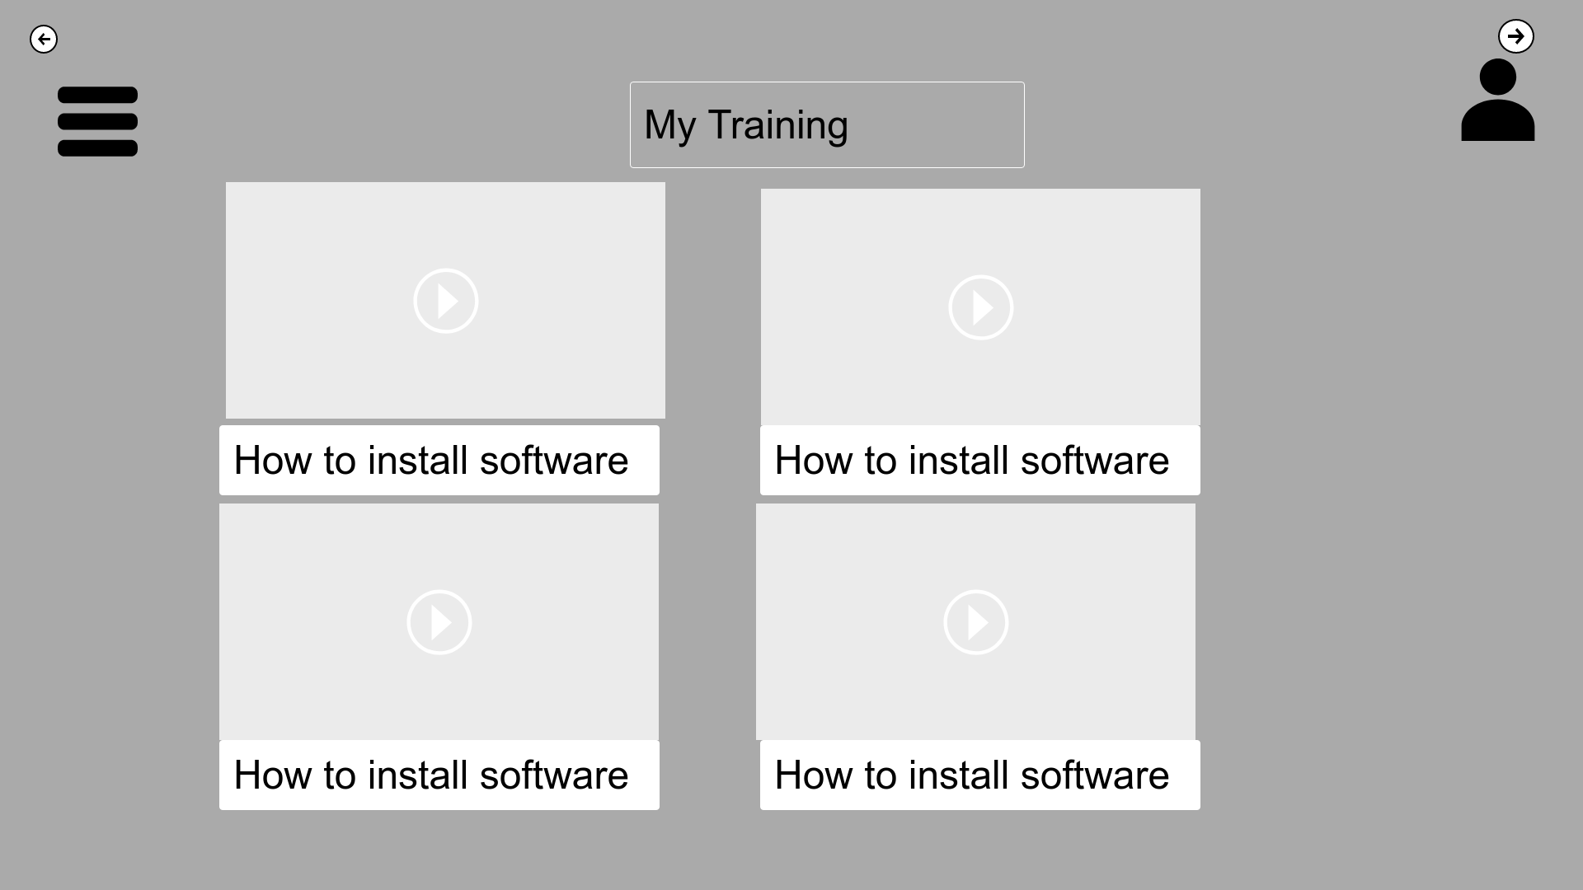

|  |  |
| --- | --- |
| Description: | The training page will have videos of the upcoming work. Any staff doing that shift will have knowledge of the work flow. |
| Content | Profile, my training, videos |
| Navigation | After pressing on any of the video it will lead to view video of clicked video. |

1. Click on video

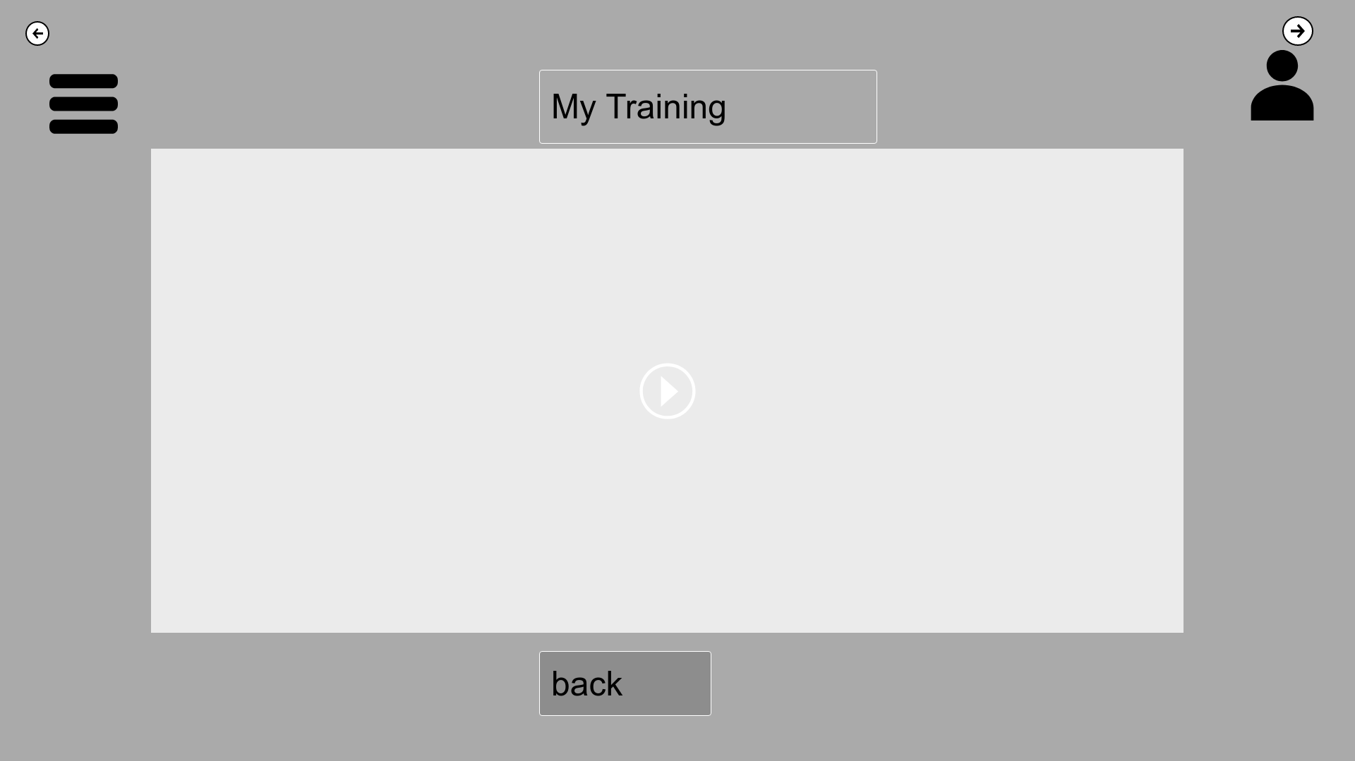

|  |  |
| --- | --- |
| Description: | After clicking on any videos from my training it will redirect to full screen of chosen video. |
| Content | Menu, my training, back, profile. |
| Navigation | When staff is lead to play video page from my training video. User can also go back to training page by clicking on back or arrow left arrow on top. |
| Graphic | Company logo on top left side. |

1. Work market 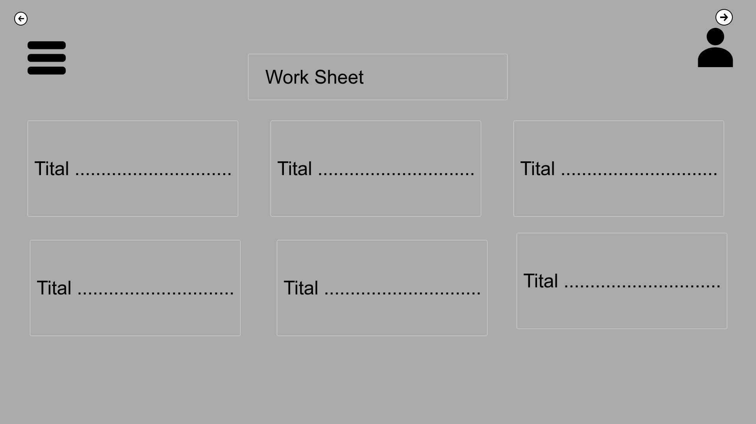

|  |  |
| --- | --- |
| Description: | This page shows the work sheet which mean available shift in the company. Staff can pick a shift from the displayed shift. |
| Content | Date, time, day, menu, profile, Clock in and clock out |
| Navigation | Navigation bar links to menu, shift detail. |
| Graphic | Company logo on top left side. |

1. Click on task

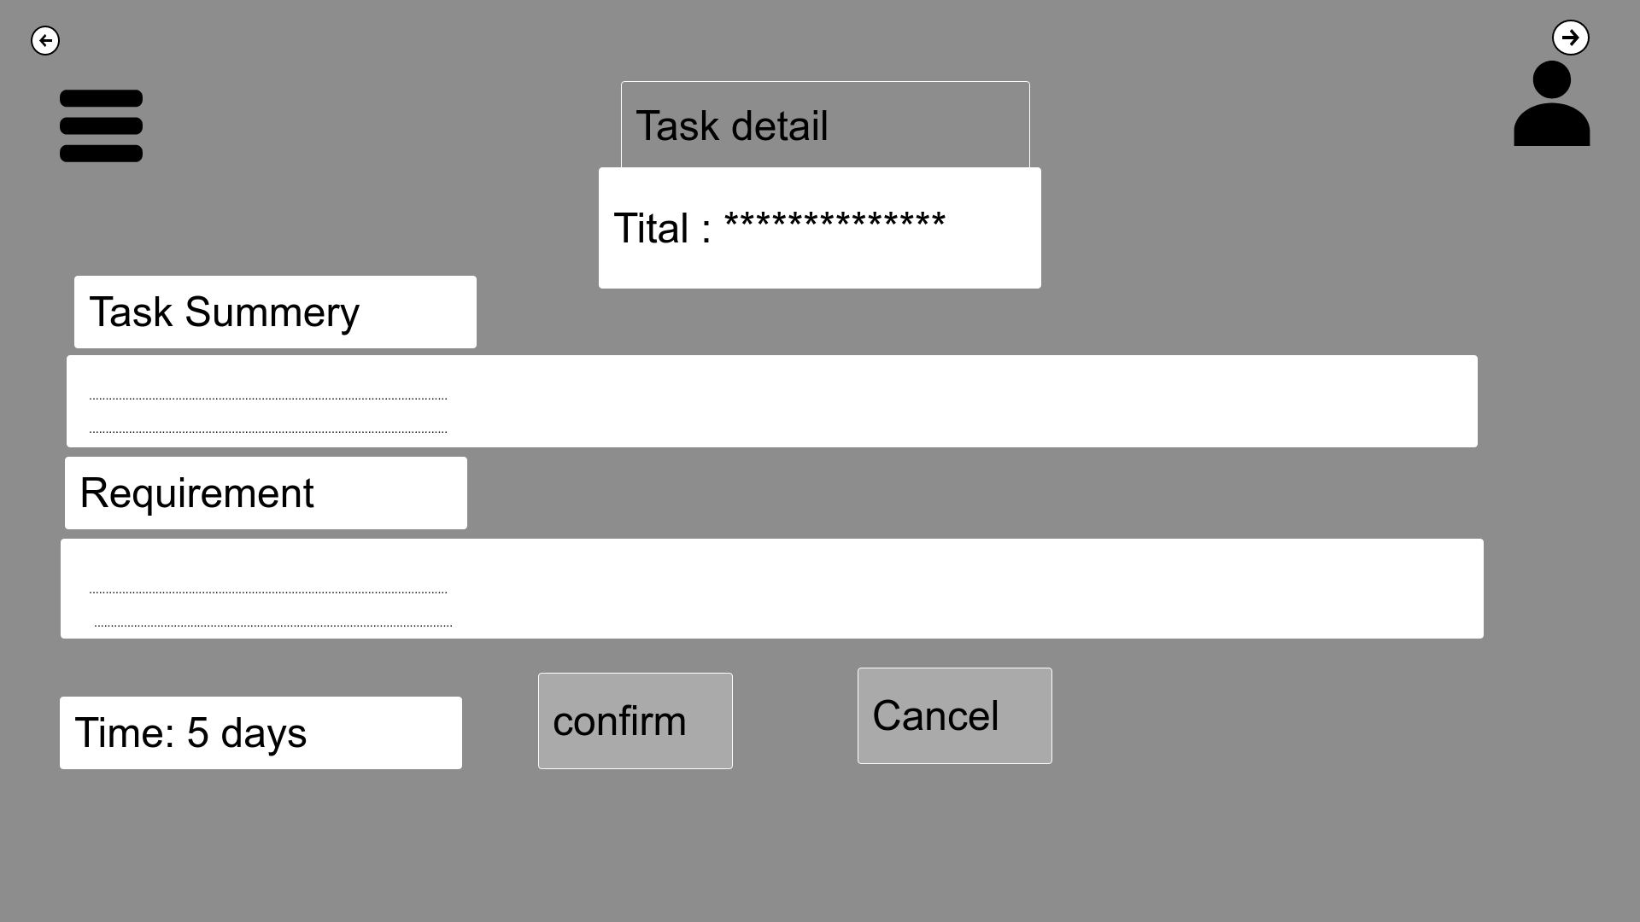

|  |  |
| --- | --- |
| Description: | After clicking on shift displayed on screen it will redirect to detail of shift which will have title, task summery, requirement, working days, confirm and cancel. |
| Content | Title, Task summary requirement, days, confirm, cancel, menu, profile. |
| Navigation | Navigation bar links to menu, profile, clicking on confirm will lead to conformation page. |
| Graphic | Company logo on top left side. |

1. Click on confirm

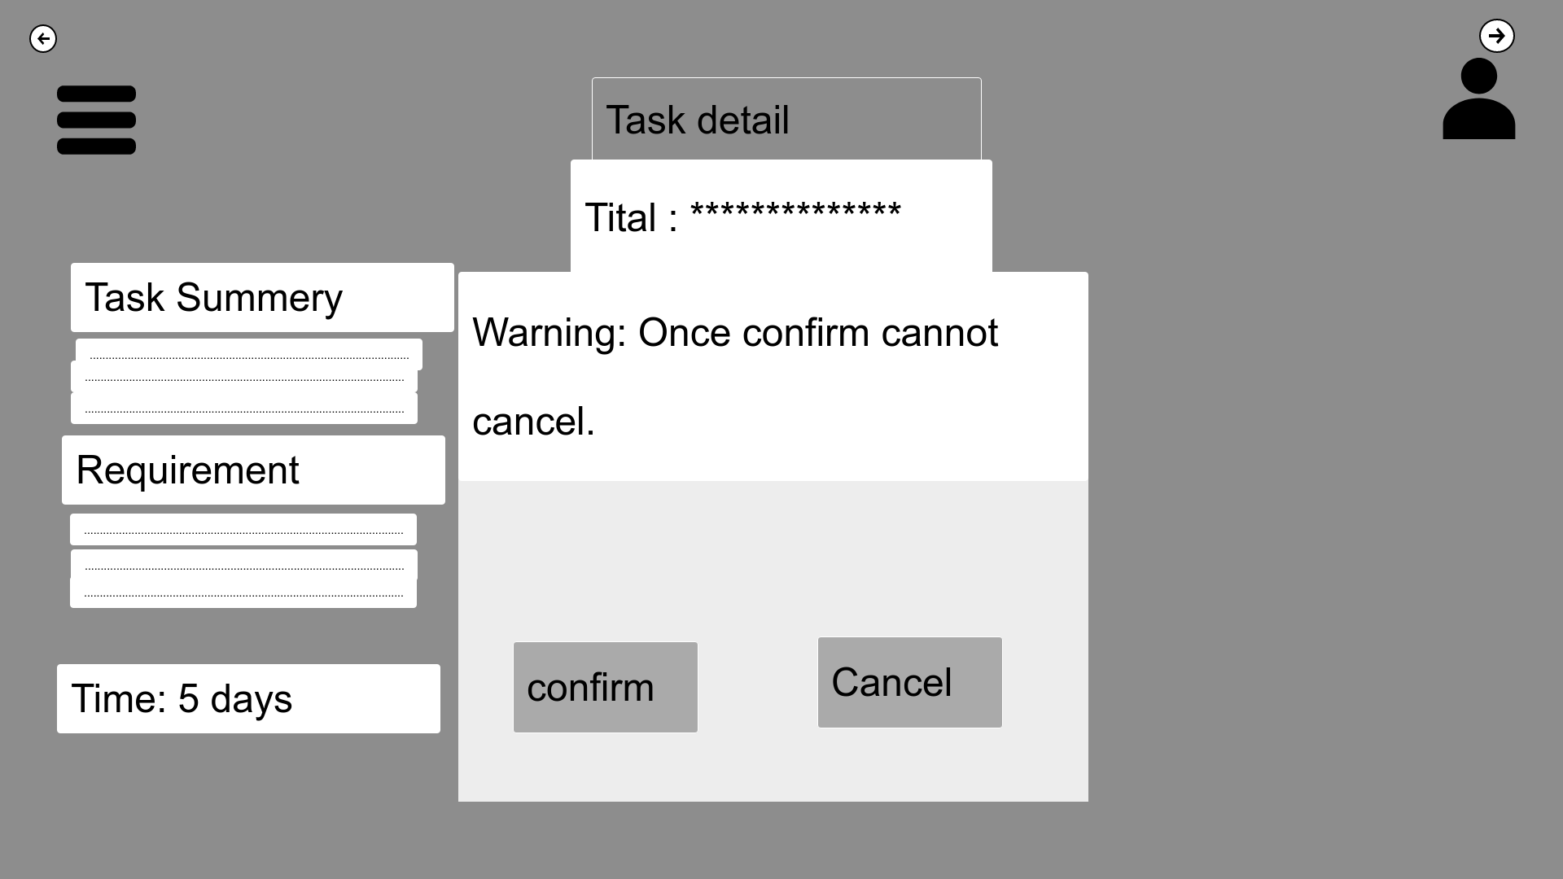

|  |  |
| --- | --- |
| Description: | After clicking on confirm the message will pop up showing” once confirm cannot cancel”. |
| Content | menu, profile, confirm, cancel, task summary, requirement, time, title, task detail. |
| Navigation | Navigation bar links to menu, profile, clicking on confirm will lead to selection of detail. |
| Graphic | Company logo on top left side. |

1. Click ok

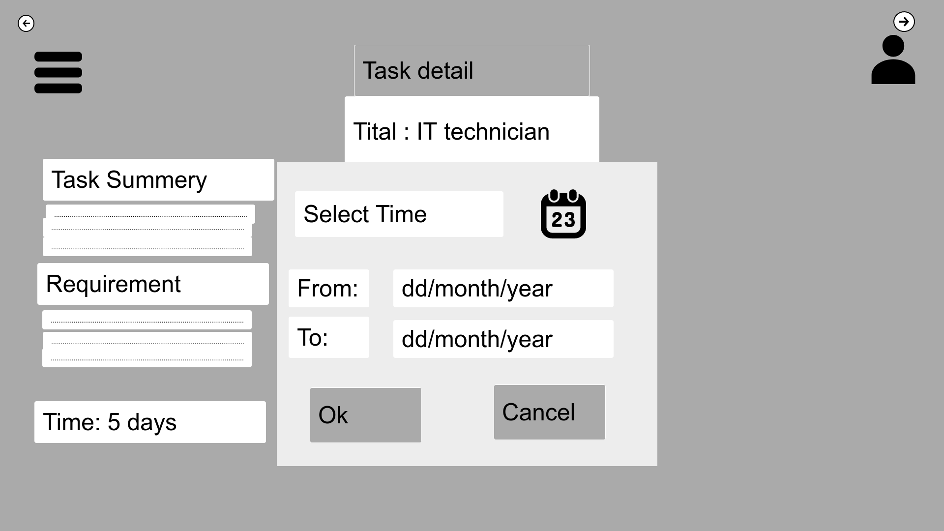

|  |  |
| --- | --- |
| Description: | This page is final page for confirmation of task. Once every detail is filled staff can click on ok to summit the data. |
| Content | Date, time, day, menu, profile, profile, menu |
| Navigation | Navigation bar links to menu, user can select the start date and end date of shift. |
| Graphic | Company logo on top left side. |